**Lab Assignment 5**

* For your programs, you can import the images from data available in Python by using the commands below:

from skimage import data

image = data.camera() # for importing cameraman image

* Reference:

Hands-On Image Processing with Python by Sandipan Dey

1. **Geometric Transforms using inbuilt functions. Refer below for running the codes:**

import matplotlib.pyplot as plt

from skimage.transform import warp

from skimage import data

from skimage.transform import SimilarityTransform

# SimilarityTransform and warp functions can be used for geometric transforms

1. **Translation:**

* Translate the input image by βx and βy = (30, -10)
* Translate the input image by (30, 10)

Under translation, an image element located at (x1, y1) in the original is shifted to a new position (x2, y2) in the corresponding output image by displacing it through a user-specified translation.

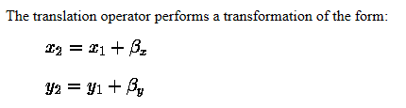

Example:

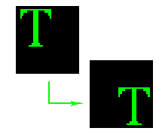

1. Scale, rotation, translation

You can use the above functions for performing these three geometric transforms together.

About scaling:

(x’, y’) = (a*x, b*y) where (x’, y’) are new coordinates after scaling, (x, y) are original coordinates, a and b are scaling factors.

1. Perform the following geometric transforms without using inbuilt functions.
2. Apply the **horizontal shear** (shear parallel to the *x* axis) on the image with shear factor = 2. It converts the coordinates from (x,y) to the point (x+my, y) where m is the shear factor.
3. Apply the **vertical shear** (shear parallel to the y axis) on the image with shear factor = 3. It converts the coordinates from (x,y) to the point (x, mx+y) where m is the shear factor.
4. Add salt and pepper noise to your input image using inbuilt function in Matlab/Python such as imnoise in Matlab. This noise is caused by sharp and sudden disturbances in the image signal. It presents itself as sparsely occurring white and black pixels. You can use the images which are already corrupted by salt and pepper noise, easily available on internet such as:

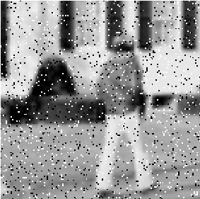

a) Write a program to implement spatial domain median filter to remove salt and pepper noise without using inbuilt functions. For every 3X3 area, find the median of the pixels and replace the center pixel by the median.

b) Apply mean filtering as well on noisy image and find out which filter gives better result for salt and pepper noise.

**Optional Problem**

Perform the same experiment as problem 1, but with gaussian noise. Depending on whether image is bright or dark, you can add different levels of noise to the image. G = imnoise(I,'gaussian',m) adds Gaussian white noise with mean m and variance of 0.01.

a) Reduce this Gaussian noise with mean/averaging filter. Study the effect of applying mean filters of 3x3 5x5, 7x7 on input images.

1. Also, study the effect of applying 3x3 median filter on the images. Compare results and note which ones are best.